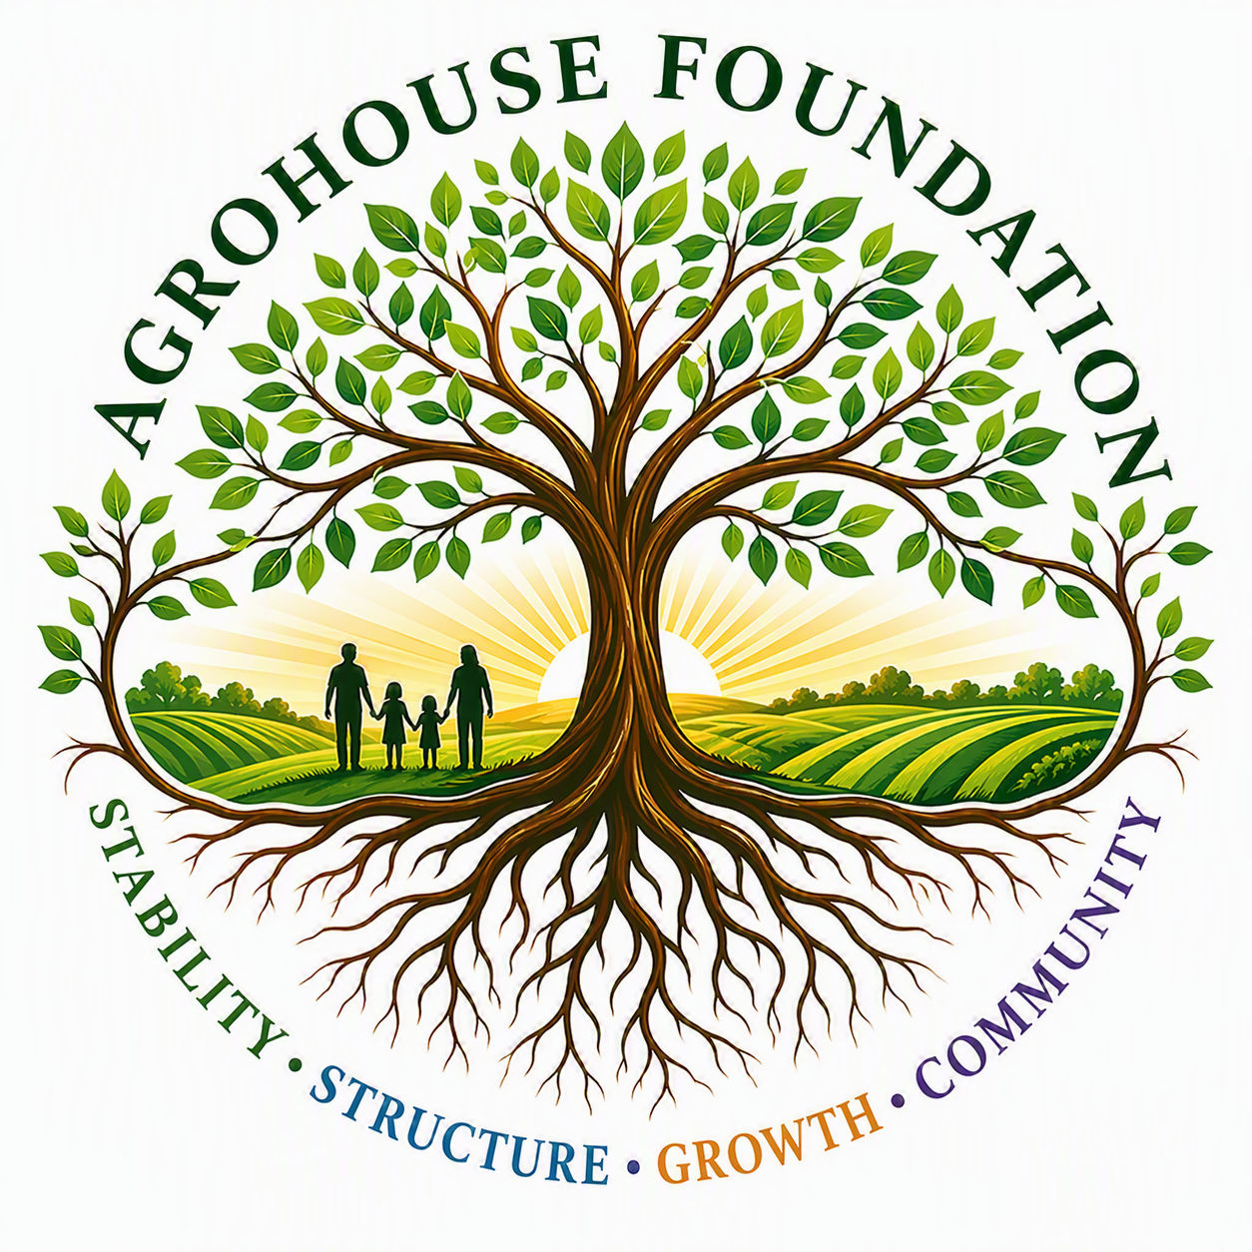
AGROHOUSE FOUNDATION
EXECUTIVE BRIEFING PACKET
Meeting with Wilton Simpson
PRESENTED BY
Susan Slater
Treasurer, AgroHouse Foundation Board of Directors
PREPARED BY
AgroHouse Foundation Board of Directors
Meeting Date: ______________________________
Executive Summary
AgroHouse Foundation (AGHF) is a Florida nonprofit organization being established to strengthen communities through a phased, debt-free model focused on community stabilization, food security, sustainable agriculture, workforce development, and future vocational housing initiatives. The Foundation's objective is to create a long-term ecosystem where these programs work together to improve self-sufficiency, community resilience, and economic opportunity.
The purpose of this meeting is to introduce AgroHouse Foundation, share its long-term vision, and seek strategic guidance regarding land acquisition opportunities, agricultural development, food security initiatives, workforce development partnerships, funding opportunities, and key introductions that can accelerate implementation of the Foundation's mission.
Mission, Vision & Core Values
Mission Statement
AgroHouse Foundation exists to strengthen communities through outreach stabilization, food security, sustainable agriculture, workforce development opportunities, and future vocational housing systems that promote long-term stability, self-sufficiency, and dignity.
Vision Statement
To create a sustainable ecosystem where outreach, agriculture, workforce development, and vocational opportunities work together to strengthen individuals, families, and communities.
Core Values
• Stability — Creating reliable systems that communities can depend upon.
• Sustainability — Building long-term solutions rather than temporary responses.
• Stewardship — Managing resources responsibly, ethically, and transparently.
• Community — Working alongside existing organizations and community partners rather than replacing them.
• Opportunity — Creating pathways for growth, education, employment, and self-sufficiency.
• Dignity — Serving individuals with respect while preserving personal choice, independence, and self-worth.
Organizational Snapshot
Legal Name: | AGHF Inc.
DBA: | AgroHouse Foundation
State of Formation: | Florida
Corporation Type: | Nonprofit Corporation
Intended Federal Status: | 501(c)(3) Public Charity (pending)
Formation Stage: | Pre-Incorporation
Operating Model: | Debt-Free · Grant-Funded · Community Supported · Mission Driven
Founder & Executive Director: | Maggie Baty
Board of Directors
Chairperson: | Maggie Baty
Vice Chairperson: | Louis Meyer
Treasurer: | Susan Slater
Secretary: | Christopher Pearce
Immediate Organizational Priorities
• Incorporation
• Employer Identification Number (EIN)
• Initial Board Meeting
• Adoption of Governing Policies
• IRS 501(c)(3) Filing
• Program 1 Launch Preparation
Current Partnerships
First Nazarene Church of Zephyrhills
Primary Contact: | Nick Deford
Current Activities: | Church-operated community outreach
Outreach Schedule: | Monday, Wednesday, Friday
Outreach Hours: | 2:00 PM – 5:00 PM
Group Activities: | 5:00 PM – 7:00 PM
Estimated Weekly Reach: | 125 Individuals (growing)
AgroHouse Foundation supports this outreach through stabilization assistance, resource development, logistics, and infrastructure planning. AGHF does not operate the outreach, supervise its volunteers, or control its programming — the Foundation's role is to strengthen an existing, trusted effort already serving the community.
Food and Fellowship
Primary Contact: | Lawrence
Relationship Status: | Early-stage discussions
Estimated Weekly Reach: | 125 Individuals (growing)
AgroHouse Foundation has begun discussions regarding future collaboration with Food and Fellowship. Areas of shared interest include:
• Food security
• Community feeding initiatives
• Volunteer engagement
• Resource distribution
• Community stabilization
• Long-term partnership development
The Foundation's goal is to build collaborative relationships with existing organizations and community leaders rather than duplicate services already being provided within the community.
Combined, AgroHouse Foundation's current outreach partnerships now support an estimated 250+ individuals per week, with reach continuing to grow.
Program Overview
Programs 1–4
Program | Name | Status
1 | Community Outreach Stabilization | Active Development
2 | Farm Infrastructure & Operations | Planning
3 | Workforce Development & Education | Future Phase
4 | Vocational Housing | Future Phase
As of July 2026, Program 1 is the only active operational program under development. Program 2 remains in the planning stage and requires future Board approval before launch. Programs 3 and 4 remain future-phase initiatives. No future program may launch without Board approval.
Program 1 — Community Outreach Stabilization
Purpose: to strengthen existing outreach efforts through the procurement and distribution of meals, hygiene resources, hydration resources, logistical support, storage solutions, and community support infrastructure.
• Food security assistance
• Hygiene assistance
• Resource procurement
• Community partnerships
• Outreach stabilization and logistics support
Program 2 — Farm Infrastructure & Operations
• Sustainable food production
• Agricultural education
• Community food resources
• Farm-based workforce opportunities
• Long-term food system sustainability
Program 3 — Workforce Development & Education
• Job readiness training
• Workforce development
• Agricultural education
• Skilled trades exposure
• Vocational learning opportunities
Program 4 — Vocational Housing
• Structured vocational housing
• Long-term stabilization
• Independent living development
• Community reintegration support
• Workforce participation opportunities
The AgroHouse Foundation Campus Concept
The Foundation seeks to identify and secure a property capable of supporting multiple integrated programs through phased development. This vision includes:
• Program 1 — Community Outreach Stabilization
• Program 2 — Farm Infrastructure & Operations
• Program 3 — Workforce Development & Education
• Program 4 — Vocational Housing
The campus model is intended to create a self-supporting ecosystem where agriculture, education, training, outreach services, and future housing opportunities work together to address long-term community needs.
Land Acquisition & Property Development
Strategic Objective
One of the Foundation's highest priorities is identifying property capable of supporting long-term community impact through phased development of all four Foundation programs. The Foundation is not simply seeking farmland — it is seeking a permanent home for a multi-program community development campus.
Property Requirements
Minimum | Preferred | Ideal
20–30 Acres | 50+ Acres | 75–100+ Acres
Potential Future Uses
Agriculture:
• Fruit and vegetable production
• Community food systems
• Agricultural education
• Sustainable farming operations
Community Outreach:
• Storage facilities and distribution operations
• Food logistics
• Volunteer operations
Workforce Development:
• Agricultural and farm operations training
• Equipment operation training
• Skilled trades opportunities
Future Vocational Housing:
• Structured residential opportunities
• Workforce participation support
• Educational integration
• Long-term stabilization programming
Food Security & School Nutrition Vision
Future Agricultural Production Goals
As agricultural operations are developed, AgroHouse Foundation intends to explore opportunities for locally grown food production that supports both community needs and educational partnerships, including:
• Fresh produce for community outreach programs
• Food security initiatives
• Community food distribution partnerships
• Agricultural education opportunities
• Workforce development training
• Local food system development
School Nutrition Discussion
The Foundation has discussed the possibility of eventually phasing in fruit and vegetable production that could support local school nutrition efforts while also creating educational and workforce development opportunities, including:
• Locally sourced produce initiatives
• School nutrition partnerships
• Farm-to-school opportunities
• Agricultural education integration
• Student exposure to agriculture and food systems
• Workforce readiness opportunities connected to agriculture
The goal is to explore how community agriculture may one day support both food security and educational outcomes within the region.
Strategic Discussion Topics
Strategic Guidance
If you were building AgroHouse Foundation from the ground up today:
? What would be your top priorities?
? What common mistakes should we avoid?
? What opportunities should we be pursuing immediately?
Land Acquisition
? Are there landowners who may be interested in charitable donation opportunities?
? Are there retiring farmers considering legacy planning options?
? Are there agricultural properties available through partnerships or long-term lease arrangements?
? Who should we be speaking with regarding available acreage?
Funding Opportunities
• Agricultural grants
• Food security grants
• Workforce development grants
• Infrastructure grants
• Community development funding opportunities
School Food System Opportunities
• Farm-to-school initiatives
• Local procurement opportunities
• School nutrition partnerships
• Educational agriculture programs
• Future program requirements and certifications
Partnership Development
Who should AgroHouse Foundation be building relationships with now?
• Florida agriculture leaders
• Food security organizations
• Educational institutions
• UF/IFAS Extension
• Farm Bureau leadership
• Community development organizations
• Workforce development organizations
• Agricultural foundations
Specific Request & Desired Outcomes
AgroHouse Foundation respectfully requests guidance regarding:
• 1. Potential land opportunities
• 2. Agricultural development resources
• 3. Food security initiatives
• 4. School nutrition partnership pathways
• 5. Funding opportunities
• 6. Strategic introductions
• 7. Community development partnerships
Would you be willing to keep AgroHouse Foundation in mind should you become aware of property opportunities, agricultural partners, funding opportunities, or organizations whose mission aligns with our long-term vision?
Desired Meeting Outcomes
Primary: Strategic guidance, industry insight, and recommended next steps.
Secondary: Property leads, landowner introductions, agency contacts, and funding opportunities.
Long-Term: Continued communication, future partnership opportunities, expanded community collaboration, and support for development of the AgroHouse Foundation campus vision.
Closing Statement & Contact Information
AgroHouse Foundation is building a phased community impact model that begins with outreach stabilization and expands into sustainable agriculture, workforce development, food security initiatives, educational partnerships, and future vocational housing opportunities. Through collaboration with churches, nonprofits, educators, agricultural leaders, and community stakeholders, the Foundation seeks to create a permanent community resource that strengthens self-sufficiency, dignity, and long-term resilience for the individuals and families it serves.
Board of Directors Contact Information
Maggie Baty, Chairperson & Executive Director: | Maggie@AgroHouseFoundation.org · 813-364-3921
Louis Meyer, Vice Chairperson: | Louis@AgroHouseFoundation.org · 913-565-0897
Susan Slater, Treasurer: | Susan@AgroHouseFoundation.org · 954-601-7209
Christopher Pearce, Secretary: | Chris@AgroHouseFoundation.org · 407-405-7096

Thank you for your time and consideration.
— Susan Slater, Treasurer, on behalf of the AgroHouse Foundation Board of Directors

